Project Rafting Site

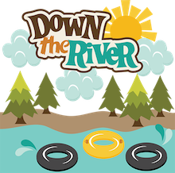

1.

2.

primary-color #BDE0D8

secondary-color #E6A827

accent1-color #733D2C

accent2-color #40231A

3.

heading-font

https://fonts.googleapis.com/css2?family=Boldonse&display=swap

Boldense

text-font

<https://fonts.googleapis.com/css2?family=Boldonse&family=M+PLUS+Rounded+1c&display=swap>

Boldense

4.

https://coolors.co/5a3a1e-e6a827-bde0d8-733d2c-40231a